URBAN ESCAPE WINS TELSTRA MICRO BUSINESS AWARD
by Shannon Gaitz on July 10, 2014 in Business, News

URBAN ESCAPE capitalised on their unique approach to luxury hair care and environmentally minded health and wellness services to claim the Micro Business Award at the Telstra Victorian Business Awards. The achievement continues a stellar year for the Aveda salon, which has already won the Australian Customer Service Achiever Award for Hairdressing in 2014.

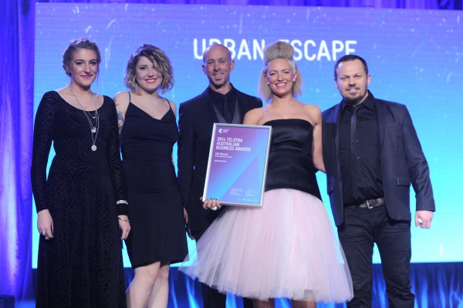
URBAN ESCAPE won the Telstra Micro Victorian Business award

URBAN ESCAPE has been successful with its dedication to both the environment and its clients and the Telstra Judges commended it for its commitment to the industry and community. The salon uses renewable resources and recycled materials, and its products are free from synthetic ingredients and petrochemicals. For this natural mentality it was named the International Green Salon of the Year in 2011 by Aveda.
The salon also benefits from its strong attitude to customer service. “A core value at URBAN ESCAPE is that the superstar is the person in the chair not behind it,” said URBAN ESCAPE Founder and Director, Craig Withers. The overall objective of the salon is to create a state of complete physical, emotional and mental well being for its clients.

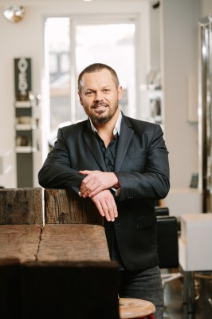

Craig Withers
The salon is looking to grow as a major brand, with team members encouraged to open their own business under the URBAN ESCAPE umbrella.
URBAN ESCAPE’s multiple achievements recognise its business savvy, client-orientated and environmentally driven mindset. Congratulations to the team.
For more information visit urbanescapehair.com or call (03) 9529 7845

One Earth.One Life.One Dream

