URBAN ESCAPE WINS NATIONAL MICRO BUSINESS AWARD
by Shannon Gaitz on August 12, 2014 in Business,News

After recently taking out the title for the state awards, Victorian hair and wellness salon URBAN ESCAPE has won the Micro Business Award at the national 2014 Telstra Business Awards. URBAN ESCAPE became the first hair salon to win at the national level of the Telstra Australian Business Awards.

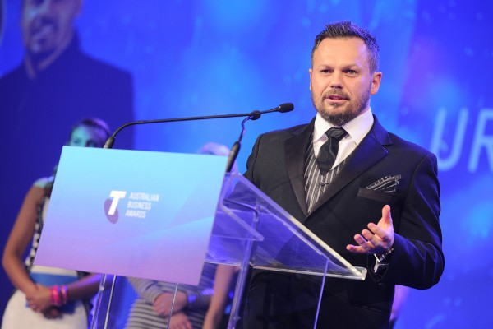
Craig Withers at the Telstra Australian Business Awards

A luxury, holistically focused hair and wellness retreat, URBAN ESCAPE opened in 2011 and has since impressed with its high level of customer care, modern aesthetic and commitment to the environment. URBAN ESCAPE only uses renewable resources, recycled materials and products free of synthetic ingredients and petrochemicals.

“I wanted to create a business which allows our customers to escape the mayhem of urban life while caring for the environment and the world we share,” said Craig Withers, who founded the salon. “From the moment you walk into URBAN ESCAPE the sensory journey begins with sustainable building materials, naturally derived and organic ingredients and value add experiences including a complimentary welcome massage and hand relief ritual.”
“URBAN ESCAPE is an outstanding business that shows 100 per cent commitment and dedication to its staff, the customer and the environment,” said Will Irving, Group Managing Director of Telstra Business and Telstra Business Awards Ambassador. “Judges were impressed by URBAN ESCAPE’s complete customer experience focus, integrated service delivery and reconception of what a great hairdressing business can be.”
An already highly decorated salon, URBAN ESCAPE has been a winner of the Aveda Green Salon Award and won the 2014 Australian Customer Service Achiever Award for Hairdressing. It has worked with leading brands such as MAC Cosmetics and Ralph Lauren at Melbourne Fashion Week.
Combining fashion credentials with lauded customer service and a commitment to the environment, URBAN ESCAPE has made history at the Telstra Business Awards. Well done to everyone involved.
For more information visit urbanescapehair.com or call (03) 9529 7845

One Earth.One Life.One Dream

